AP JAPANESE LANGUAGE AND CULTURE 2022-2023
Roswell High School Teacher: Seiko Onuki (Onuki Sensei) Room: 623

TEACHING PHILOSOPHY AND COURSE OVERVIEW
The aim of the AP Japanese Language course is to improve students’ language skills and prepare them for the AP exam offered by the College Board in May 2023. The AP Japanese exam includes language and a strong cultural component centered around interdisciplinary themes. The format of the exam will reflect Communication as defined in the Standards adopted by the American Council on Teaching of Foreign Languages (ACTFL): Interpersonal, Interpretive, and Presentational.

This year we will use strategies that adjust to individual student needs and learning styles as we lead our students to communicative and cultural competency. We use a variety of authentic audio and video recordings and authentic written texts from newspapers, magazine articles, and literary texts in addition to our current textbooks. We strive to create contextualized and thematic lessons which incorporate interdisciplinary topics. We will provide opportunities for collaborative interpersonal, interpretive, and presentational work.

Japanese will be used almost exclusively from the beginning, and I require the students to do likewise. The course is designed to prepare students to use Japanese in real-life settings. It will help students broaden their world view by comparing cultural products, practices, and perspectives with those of their own society and language.

Students will be exposed to a wide variety of written material including full length and excerpts from literary works, online publications, and media texts. Reading is the foremost vocabulary builder; it makes the language and culture come to life. A variety of techniques will be used to ensure that cultural concepts, new vocabulary and idiomatic expressions are being learned – from written assessments to question and answer periods, oral presentations and guided discussions. Students must analyze, summarize, and draw conclusions from the material they have read. Information and ideas are presented by students to their classmates in the form of presentations as well as discussions in which students must defend the position they assume.

EVALUATION
Students are trained to work with AP rubrics and use them to perform self and peer assessments. As May approaches, students will practice test-taking techniques to become familiar with the different sections of the exam.

Homework is an important aspect of our learning experience. Grammar exercises, study of vocabulary terms, reading of literary and non-literary works prior to discussion, rewriting rough drafts for compositions, are all units of homework. Students work collaboratively to discuss possible answers to the homework.

COURSE THEMES – We will spend about
5-6 weeks on each AP Theme and its sub-themes
Unit 1 – Families & Communities: Family Structure; Roles within Families; Social Customs; Traditions; Values; Rites of Passage
Unit 2 – Personal and Public Identities: Heros and National Figures; Self-image and the Role of the Individual in Society; Gender and Gender Roles
Unit 3 – Beauty and Aesthetics: Visual and Performing Arts; Traditional and Contemporary Arts and Music; Defining Beauty – Perspectives of Beauty in Japanese Culture; Fashion and Design
Unit 4 – Science and Technology: Technology and Access to Technology; Climate and the Physical World
Unit 5 – Contemporary Life: Lifestyles and Pop Culture; Education and Careers; Holidays and Celebrations
Unit 6 – Global Challenges Population and Demographics; Obtaining, Managing, and Protecting Resources

Students will receive a weekly plan with theme, resource materials, activities and assessments. (Teams and packet)

MATERIALS/SUPPLIES/RESOURCES
- Your school issued device
Access to: OneNote - Join the AP Japanese class. All the study materials will be posted on class OneNote or distributed in a paper packet/handout
Teams: Every student will be required to belong to the class Team. This space will be used throughout the year for Universal Remote Learning, announcements, assignments, and resources.
College board- AP Japanese class: (please use your existing account!)
I recommended that you create and keep a notebook (or file) paper or electronic for Thematic Units. You will need access to your articles, notes, songs, poems to study for the AP exam in May. You will also need colored pens and highlighters for corrections and editing of written work.

TEXTBOOKS:
Main Texts:
Peterson et. al. “Dekiru: An AP Japanese Preparation Course.” Cheng & Tsui Company, 2018.
Banno et.al. “Genki II: An Integrated Course in Elementary Japanese.” The Japan Times, 2014.
Banno et al. “Genki II Student Workbook.” The Japan Times, 2014.

Additional Texts:
Peterson et. al. “STRIVE FOR A 5. AP Japanese Practice Tests” Cheng & Tsui Company, 2009.
Banno et al. “Kanji Look and Learn.” The Japan Times, 2013.

NEWS PAPER / MAGAZINES:
Asahi Gakusei Shimbun (Asahi Students Newspaper)
High School Times
Animate Times

WEB ARTICLES :
Excerpts from the following reflect curriculum, student interests
http://www.nhk.or.jp/school/
https://www3.nhk.or.jp/news/easy/
https://hirogaru-nihongo.jp/en/
https://www.japanese.io/news
https://www.kanji-link.com/
https://www.tofugu.com/
https://www.tjf.or.jp/clicknippon/ja/
http://web-japan.org/kidsweb/
https://www.nippon.com/ja/
http://www.nihongo123.com/
http://www.highschooltimes.jp/
https://hirogaru-nihongo.jp/
www.asagaku.com

FILM SELECTIONS: (excerpts or entire film)
NHK Documentaries
Movie 「パパのお弁当は世界一」(My dad’s boxed lunch is the best)

ART RESOURCES: (excerpts or entire film)
Easy Japanese Rakugo (https://yasashii-nihongo-rakugo.jp/)

Grades:
Grade weights:
Assignment type | Grade weight
Major assessments – practice tests in AP Central, essays, projects, presentations | 60%
Minor assessments – Quizzes, role plays, mini-projects and presentations, emails | 30%
Practice/HW | 10%

Teachers will note absences or incomplete/missing assignments in Infinite Campus

Grading scale: 90-100 A 80-89 B 70-79 C 0-69 F

Testing Days: Test days for major assessments for the World Language Department are Tuesdays and Fridays.

The following grade conversion scale will be used for most assignments.
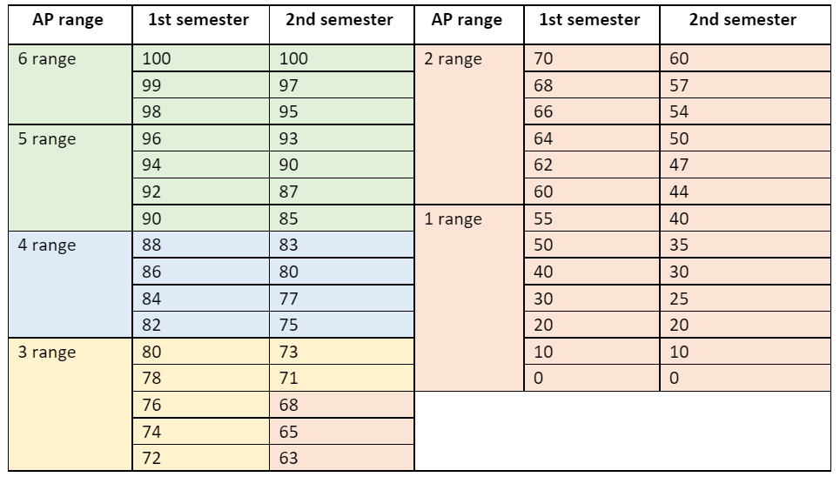

RHS Academic Honesty Policy
Academic dishonesty on a major assignment will be reported to the grade level administrator. The administrator will contact the student to follow due-process requirements and document it in the student information system as appropriate. The student will then be given the opportunity to re-do the assignment for full credit.
In this class, academic dishonesty (cheating) includes using Google Translate (or any online translation tool) for anything other than word search, copying someone else’s class work or homework, allowing others to copy one’s own work, communicating with others during a test or quiz, using any unauthorized materials on tests and assignments and plagiarism. If students or parents have any questions about this policy, they should contact Onuki Sensei.

Absences: It is important for students to be present in every class, but especially in world language classes where we build new foundations for future language skills every day. However, if it is necessary for a student to be absent, it is the responsibility of the student to make up any missed assignments, quizzes or tests.
- When a student returns to school after an absence, he or she is expected to turn in any assignments (homework or projects), due during the absence.
- Arrangements to make-up tests or quizzes must be made when the student returns to class.
- Being absent the day before a scheduled test does not excuse a student from taking the test.

Recovery policy:
All students will have at least one (1) opportunity each nine weeks to redo/retake one (1) major assignment/assessment.
- Eligibility for a redo/retake is for students who receive a 79 or below on a specific major assignment/assessment.
- Students are eligible to earn a replacement grade on a redo/retake no higher than 79.
- Student redo/retakes must be completed before the next major assignment/assessment is given or five (5) school days before the end of a marking period if there is not another major assignment/assessment given (exceptions can be made for students who have excused absences during this five-day window).

Class expectations:

- Students are expected to demonstrate maturity, responsibility, and respect for others. The work that they submit must be their own.
- Come to class on time and prepared.
- Please be mindful of the daily class routine.
- By the class start time, be in a quiet place and ready to learn, with all your materials out and at hand.
- Check the OneNote (in Teams) Welcome page for agenda.
- Begin work on our daily warm-up activity.
- Please listen carefully and treat others with respect. Please do not talk over your peers or the teacher.
- FCBOE policy prohibits the recording of photographing of anyone without written permission from school Administration.
****Important dates for College board*********
- August Join AP Japanese class on College board website- use your existing account.
- October - Students will declare their intent to take the AP Japanese exam. The default setting is YES, so you will need to contact Ms. Phairr on/before that day.
- November - after November 15, students incur a $40 cancellation fee if they decide later not to take the exam OR a $40 late registration fee.

Teacher Contact:
You can reach me by e-mail (onukis@fultonschools.org) and I will respond withing 24 hours. *Note that I will not see your email after 4pm until the next day. If it is a pressing question, please text it to me in our class Remind and I will respond. Parents and students should consult Infinite Campus to access student grades.

